CAMPUS NAVIGATION SYSTEM
GRAPHS:
- Graphs are basically used to represent networks, navigation (in our case) and organisation.
- G=(V,E) This is how graphs are usually represented.
V represents the number of vertices.(nodes)
E represents the number of edges.
- In our project we represent the blocks of campus, other places as nodes and the paths that lead to them as the edges.
- There are several types of graphs,
We use here Undirected Weighted graphs.
The reason is we use the graphs to navigate through two
places not only in uni-direction.
- There are two primary ways to represent the graph:
Adjacency Matrix
Adjacency List
- The campus navigation system here uses the Adjacency list because the campus pathways are sparse.(Number of edges is much smaller than the square of nodes)
- Since the graph here is weighted each edge will hold a weight (cost,distance,time,etc)
- Adjacency List:
Here basically it has a group of lists linked together.
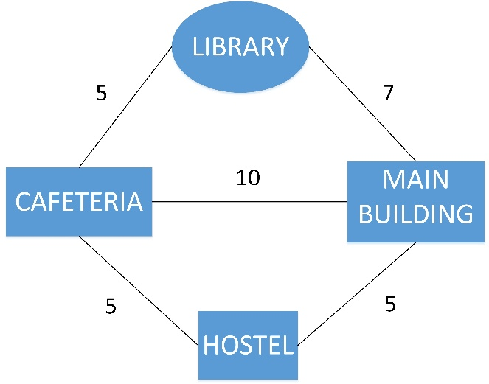
From the picture above we can form an Adjacency list as
[(Library,5),(Main building,10),(Hostel,5)] when seen from Cafeteria.
- Likewise there is Adjacency Matrix too. But that is not used here because of its inefficiency in storage.
- Graph Traversal:
Exploring all paths – DFS (Depth First Search)
Visiting neighbour nodes first – BFS (Breadth First Search)
DIJKSTRAS’ ALGORITHM:
- This algorithm is used in weighted graphs(in our case) where it helps us to find the shortest distance from one node to another in the graph.
- The reason for specifically using this algorithm is that it works on the weighted graphs (non-negative weights)
- Since we measure the campus of size almost 400 acres we will require to use the Priority Queue(Min-Heap).
- Time complexity for it - O((V + E) log V)
- What is the use of Priority Queue here?
Basically in normally terms when we use this algorithm it will
sequentially check out all the nodes one by one and then it will find
out the shortest path.
But when we use the Priority Queue what happens is that the
smallest distant node is always proceeded first.
So the time complexity is reduced from O(V²) -> O((V+E)log V)
- There is another optimization can also be done which is Bidirectional Dijkstra.
Here the methodology is like we start the search from both the
nodes.
That is it starts from both source node and the destination node. So
that it significantly reduces the time. The path with the shortest
time requirement is obviously the shortest path.

METHODOLOGY:

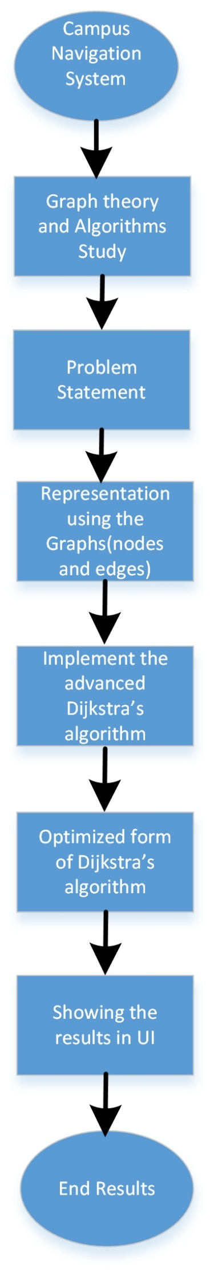
JAVA FX:
JavaFX is a Java-based framework used for building modern desktop applications with rich graphical user interfaces. It provides a variety of UI components such as buttons, text fields, charts, and tables, making it suitable for creating interactive applications. JavaFX supports CSS for styling, FXML for defining UI layouts, and WebView for embedding web content, making it flexible for different application needs. In our Campus Navigation System, JavaFX is used to visualize the campus map, allow users to select locations, and display the shortest path dynamically using Dijkstra’s algorithm. With its support for animations, real-time updates, and data visualization, JavaFX enhances the user experience by making navigation more interactive and intuitive.


A model GUI developed using JavaFX.

Like wise we will be implementing our java codes and represent them visually using JavaFX.

DATA STRUCTURES USED:
Data Structure | Purpose | Usage
- Graph (Adjacency List) | Campus Navigation | Efficient for storing locations & paths (O(V + E) space complexity)
- Priority Queue (Min-Heap) | Dijkstra’s Algorithm | Ensures shortest path selection (O((V + E) log V) time complexity)
- HashMap | Storing distances & paths | Fast O(1) lookups nearby
- ArrayList | Storing neighbours in the graph | Fast edge iteration
- Stack | Depth-First Search (DFS) | Used for deep path exploration
- Queue | Breadth-First Search (BFS) | Used for level-wise exploration

